Client Health History & Foot Zone Student Intern Disclosure Form

Name______________________________Phone#__________________Birthdate___________

Address_________________________________________City/State/Zip___________________

Email_________________________________________Referred by_______________________

Essential oils? Y/N Diffused EO? Y/N EO on Skin? Y/N

Is this your first Foot Zone? Y/N

Preferences (blankets, pillows, talking, music)_________________________________________

List any medications that you are taking:_____________________________________________

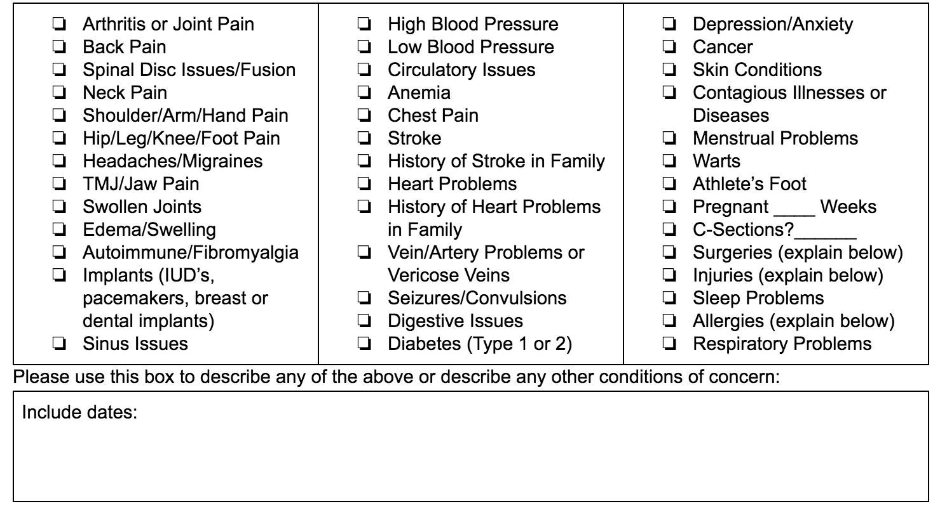

- I understand that _________________________________is a foot zone practitioner trained by Wellness Life Zone, Foot Zone Academy.
- By signing this form I give my consent to receive a foot zone, and understand that all information provided is confidential.
- It is my responsibility to inform the practitioner if there is any pain or discomfort in the foot zone session.
- I understand that a foot zone should not be considered as a substitute for medical examinations, diagnosis, or treatment and that I should see a qualified healthcare provider for any medical or mental issue I am aware of.
- I understand that a foot zone practitioner is not qualified to diagnose, prescribe, or treat for any physical or mental illness, and nothing said during any session should be considered as such.
- At any time, a practitioner has the right to refuse service for any reason.
- Because foot zoning can be contraindicated under certain medical conditions, I affirm I have disclosed all known medical conditions, and answered all questions honestly. I agree to keep the practitioner updated on any changes to my medical profile, and understand there shall not be liability on the practitioner’s part if I forget to do so.

Print Name____________________________Signature________________________________ Date____________

Consent required for treating minors:

Printed Name of Guardian__________________________________

Signature of Guardian___________________________________Date_______________

