HISTORY OF FOOT ZONE TECHNIQUE

(Foot Zone Technique is considered to be an advanced form of Reflexology. Foot Zone Technique was originally called Foot Zone Therapy, but because the medical world opposed the use of the word “Therapy” several experts have opted to change the name, some include: Foot Zone Technique, Foot Zone Balance, and Footzonology. For the purposes of this article “foot work” mentioned may be referred to as Foot Zone Technique, Foot Work, Foot Zoning, or Reflexology.)

ANCIENT FOOT ZONE HISTORY

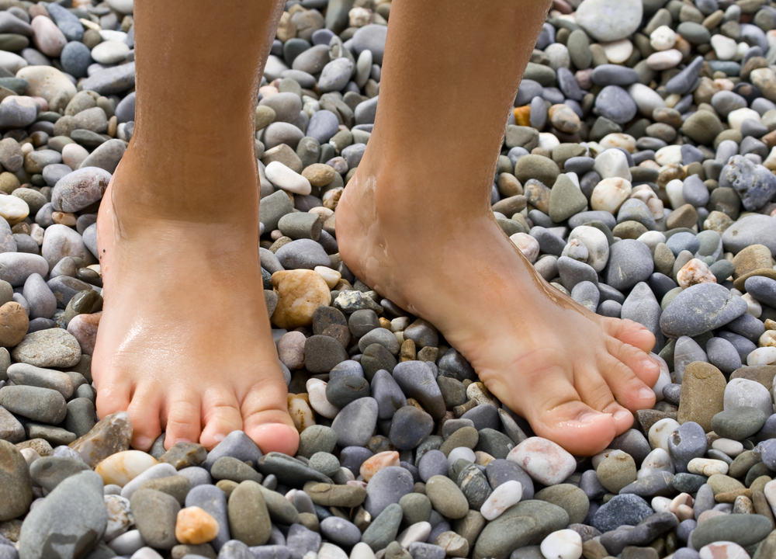
Foot Zone Technique, or a form there of, has been found and documented around the world and throughout history. It is hard to say where or when foot zoning started because not all civilizations have written records, but through oral traditions this knowledge has been passed down from generation to generation. Egyptian, Indian, Chinese, Japanese and European cultures have left trace clues about their use of triggering signals on the feet to promote health.

Many experts believed that some form of foot zoning began with man’s earliest existence. Man would trigger signals naturally by walking barefooted on rough and rugged ground. Today, because of modern transportation, smooth walkways, and cushioned shoes, these signals are not triggered naturally as often and intensely as they once were.

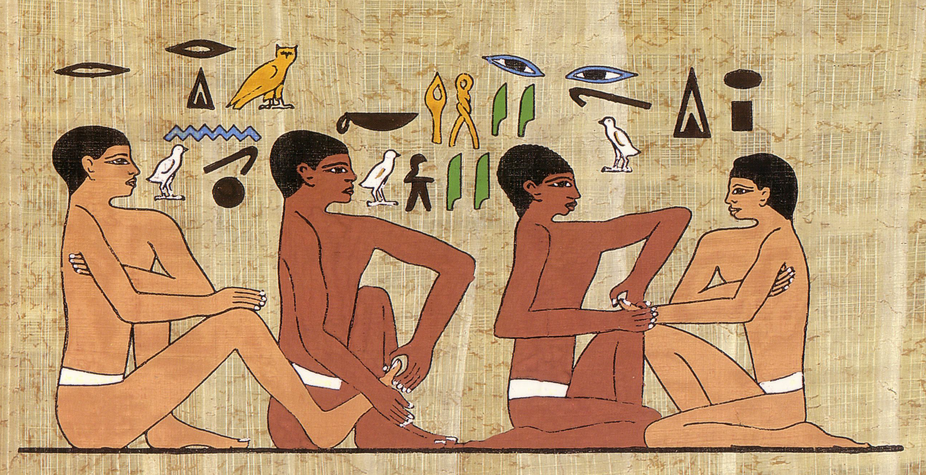
EGYPT

One of the oldest documentations of foot zoning can be found in Egypt. After touring Egypt in 1979, Ed and Ellen Case of Los Angeles brought back an ancient Egyptian papyrus scene depicting medical practitioners treating the hands and feet of their patients dating 2,500 BC.
Here is a commercial reproduction of the pictograph found in the Physician
Ankhmahor’s tomb in Saqqara, Egypt. The hieroglyphic above the scene reads:
“Do not let it be painful.” With a reply, “I do as you please.”

There is further evidence that can be found on the tomb walls of the Physician Ankhmahor. Located in the tomb are six carvings depicting, childbirth, pharmacology, embalming, circumcision, dentistry, and foot zoning.

INDIA

In India, the feet of Buddha have symbols representing life and the flow of energy (Chi) to live well. Chi is the electrical energy that flows in and out of the body. The symbols are not trigger points, but they do seem to be placed in areas on the feet where a Foot Zone Practitioner might work.
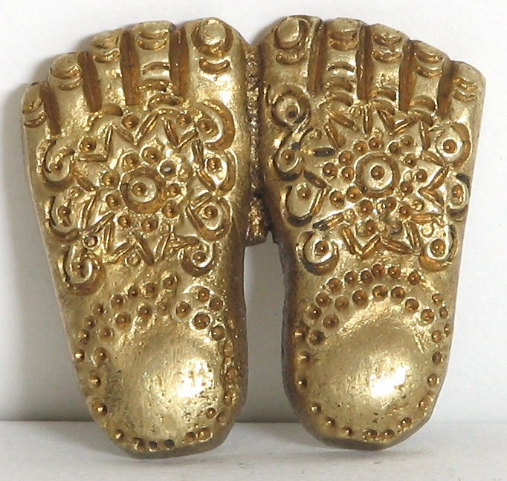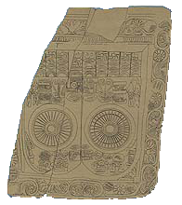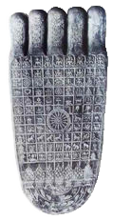

CHINA

There is early evidence of Chinese Reflexology that dates back to the 2nd Century B.C. Anciently, the famous Dr. Yu Fu treated patients without the usual use of herbs and acupuncture but concentrated solely on massage. The Chinese still incorporate the ancient traditions of Chinese Reflexology as a means of preventing and curing diseases and preserving health.
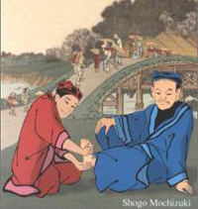

JAPAN

During the Tang Dynasty (618-907 A.D,) a Japanese monk, named Tai Tien Chiu Shao traveling in China is given credit for introducing Chinese Reflexology to Japan upon his return home. There is an accepted Japanese proverb that says, “The foot is the gate of ten thousand different illnesses.”

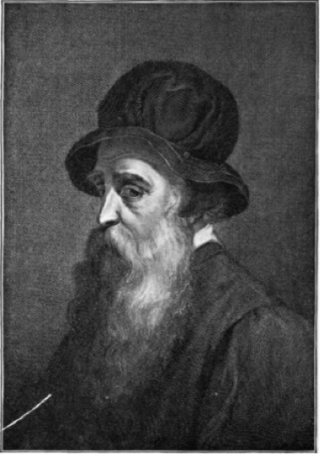
EUROPE

It is hard to say exactly how Foot Zoning entered Europe. Some experts say it was the result of Dominican and Franciscan missionaries who travelled to China and others say Marco Polo introduced it after traveling widely in China from 1275-1292. One of the earliest books to be written on Reflexology was published in 1582 by two European physicians, Dr. Adamus and Dr. A'tatis. A second book by a Dr. Bell was published shortly after this in Leipzig.

Cellini, a Florentine sculpture, is said to have used
pressure on his fingers and toes to relieve pain in his body.

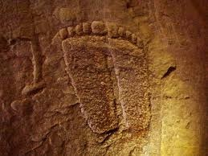
NATIVE AMERICA

Some Experts believe that in the Western Hemisphere the Inca and Mayan Civilizations practiced foot zoning. Jurgen Kaiser, who is a balneologist, massage therapist, and reflexologist, believes that an altar located at Copan, Honduras, shows engravings of Mayan Foot Zoning.
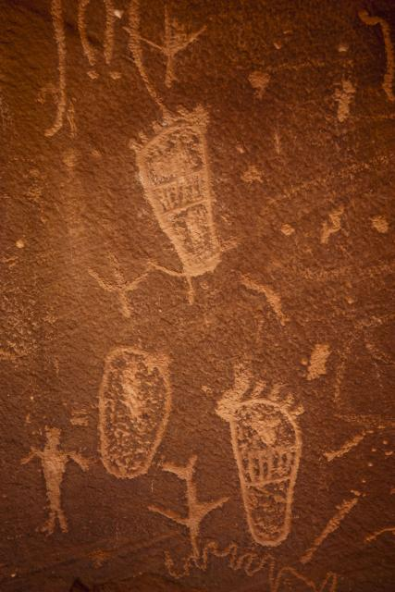
Many Native American Tribes have passed down oral histories of Foot Zoning. The Native Americans have traditions of bathing and treating their feet to restore balance to the body. The Bear Clan of the Cherokee Nation has a custom of healing using a pressure therapy of the feet. This custom has been passed down for generations in Jim Roll’s family since the late 1600’s. He learned this custom from his great grandfather, “Corn Dog” Henderson.

A Cherokee woman from the Blue Ridge Mountains of North Carolina, Jenny Wallace believes that, “Walking upon the earth connects people to the universe and that our feet keep us connected to the roots of life itself.”

Petroglyphs of the feet have been found in Southern Utah.
Some even look like they could be an ancient foot zone map.
MODERN DEVELOPMENTS IN FOOT ZONING

In the mid to late 1800’s, many medical scholars became interested in the workings of the brain. This interest in the brain led to discoveries that helped give birth to the science of Neurology and Psychology. The sciences of Neurology and Psychology would later separate into distinct fields of study. The modern study of Foot Zoning had its roots develop during this same time period.

RUSSIA

In Russia, two noted doctors; Ivan Pavlov (1849–1936) and Vladimir Bekhterev (1857–1927) pursued the study of reflexes. Their study focused on the psychological and physiological aspect of reflexes. Ivan Pavlov developed the theory of conditioned reflex response, which earned him the Nobel Prize in 1904. Pavlov’s famous theory speculated that a reflex action was a simple and direct relationship between a stimulus and a response. Pavlov’s most famous study was that of the ringing of a bell, which would cause a dog’s reflex reaction to salivate.
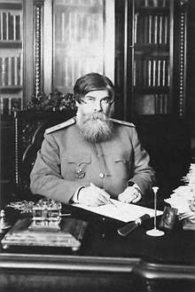
Vladimir Bekhterev was an outstanding neurologist, physiologist, psychologist and founder of reflexology in Russia. Bekhterev, independently of Pavlov, developed a theory of conditioned reflexes and invented the term “reflexology”, which he defined as a scientific discipline that studies the response to external or internal stimuli.

Bekhterev’s study of the reflexes originated from a psychological perspective. He was always convinced that there was no distinction between nervous and mental diseases. Bekhterev claimed that nerve diseases were often accompanied by mental disorders. In his 1907 work, “The Objective Psychology”, was translated into English in 1932 under the title of “General Principles of Human Reflexology”. Bekhterev believed that reflexes, which could be observed and analyzed, accompanied all mental processes.

Vladimir Bekhterev died on December 24, 1927. There is a legend that shortly before his death, Bekhterev diagnosed Joseph Stalin with paranoia. Some researchers connect this legend with the sudden death of Bekhterev.

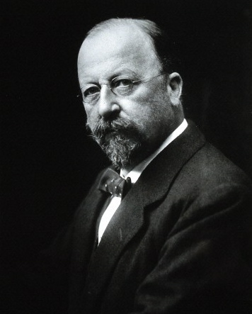
SIR HENRY HEAD, 1861–1940

Sir Henry Head, an English neurologist who pioneered work into the somatosensory system and sensory nerves. With the help and collaboration of psychiatrist W. H. R. Rivers, the two of them mapped sensations of how damaged nerves healed and how sensation returned. At one time, Sir Henry Head used himself as the student subject, allowing Rivers to severe cutaneous nerves in his left forearm and document the healing process.

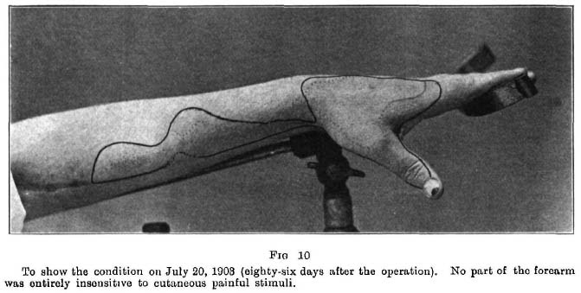
Sir Henry Head first studied sensation from a physiological prospective, using his training from Prague and Cambridge. As he progressed with his studies, Head became aware that psychological factors also had a major part to play. (Could it all be in the head?)

Sir Henry Head was curious to see if there was a connection between the pain of visceral disease (internal organs) and herpes zoster (shingles). In a careful study with A.W. Campbell, Sir Henry Head demonstrated the neurological relationship that exists between the skin and the internal organs.

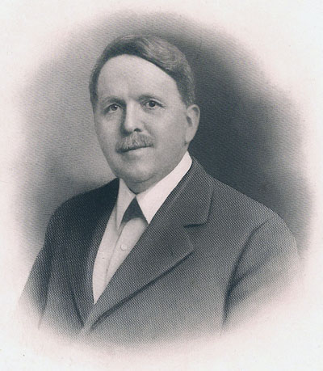
DR. WILLIAM FITZGERALD, 1872-1942

Foot Zone Technique has its origins in Zone Therapy. An Ear, Nose and Throat surgeon, Dr. William H. Fitzgerald, pioneered Zone Therapy. While Fitzgerald was head of the Nose and Throat Department of St. Francis Hospital in Connecticut, his discovery of the Chinese method of Zone Therapy was brought to the attention of the medical world. Fitzgerald pointed out the fact that pressure of certain zones, has a definite effect in bringing about normal physiological functioning in all parts of the zone that were treated.

Fitzgerald discovered and claimed an interesting fact, namely that the application of pressure on the zones relieved pain and in the majority of cases also relieved the underlying cause as well. From this theory he divided the body in 10 equal zones running from the top of the head to the tips of the toes; the theory being that reflexes operate along these zones and that pressure and stimulation of a reflex could relieve pain affecting organs, body parts and glands within a given zone.

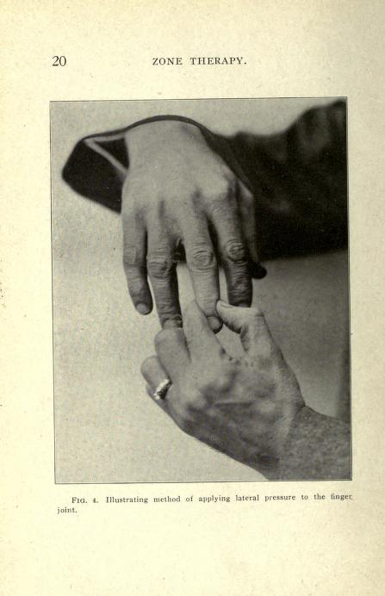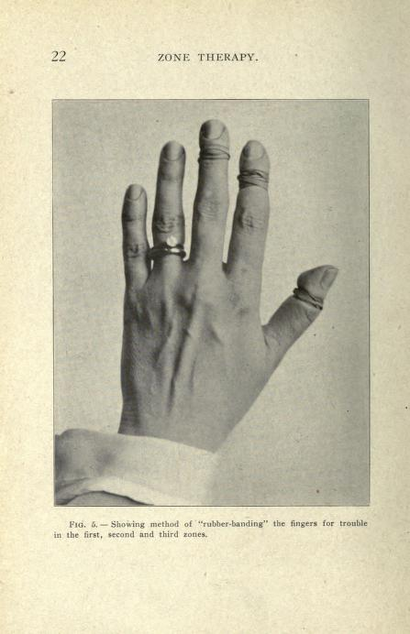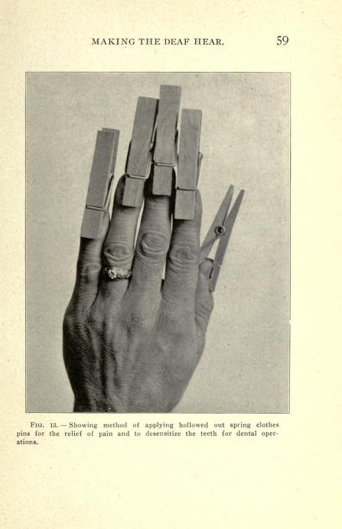
Dr. FitzGerald showed how a pressure of between 2 and 10 pounds on a given finger or toe could alleviate pain anywhere in the corresponding zone in the body. Dr. Fitzgerald used Zone Therapy to deaden pain, replacing drugs in minor operations.

In 1915, the article "To Stop that Toothache Squeeze Your Toe", published in Everybody's Magazine written by Dr. Edwin Bower, first brought Dr. Fitzgerald's work on zone therapy before the public.

In 1917, Dr. Fitzgerald wrote “Zone Therapy or Relieving Pain in the Home”. Two years later, they enlarged this book and published it under a second title “Zone Therapy or Curing Pain and Disease”.

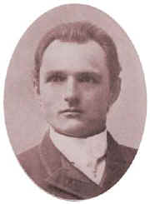
DR. JOSEPH SHELBY RILEY, 1889–1946

Dr. Joe Shelby Riley was a naturopathic practitioner who embraced all aspects of naturopathic medicine. Dr. Riley introduced the field of acupuncture into naturopathy and after attending one of Dr. Fitzgerald’s seminars in the early 1900’s he became an advocator of zone therapy. He began doing his own clinical research and implementing his techniques and procedures with zone therapy.

It seems that he added 8 horizontal zones across the hands and feet, together with the longitudinal zones and thus determined individual reflexes according to Zone Therapy.

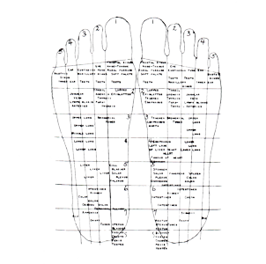
Riley and his wife, Elizabeth ran a school in Washington DC with a curriculum that included medicine, surgery, physiotherapy, chiropractic, zone therapy, osteopathy, naturopathy, electro-therapy and color and light therapy. During his lifetime he wrote twelve books on Zone Therapy, the first in 1917 the last in 1942.

EUNICE INGHAM, 1889 – 1974
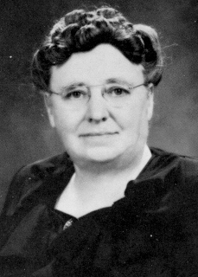
Eunice Ingham was a student of and worked for Dr. Joseph Shelby Riley as a nurse and physiotherapist. Ingham made the startling discovery and claimed that pressure points on the human foot were situated in a mirror image of the corresponding organs of the body with which the respective pressure points were associated. She found that using an alternative pressure would promote healing instead of using pressure to create a numbing effect. Ingham documented her findings, which eventually became the basis of her book “Stories the Feet Can Tell”, published in 1938.

With the encouragement of Dr. Joseph Shelby Riley, she took her work to the non-medical world, giving seminars up and down the East Coast. She was always uncomfortable using words that may get her in trouble with the medical world. That is why she eventually called her work “Reflexology” instead of Zone Therapy. This is how she became known as the “Mother of Reflexology’.

DR. CHARLES ERSDAL
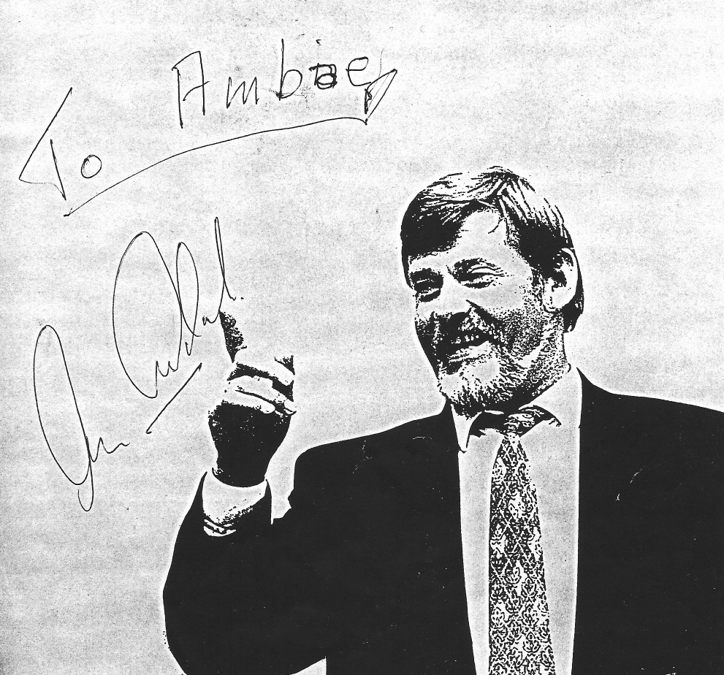
1939-1995

A young man, named Charles Ersdal from Norway, suffered paralysis of the left side. The modern medical treatments that Ersdal underwent could not cure him. He turned to Einiar Svendsen, a chiropractor and reflexologist. Svendsen worked with Ersdal using reflexology for two years and was finally brought back to good health.
Personally signed photo by
Dr. Ersdal to Amber Jensen.

This event in Ersdal’s life gave him the ambition to attend the European College of Natural Medicine in Germany. He studied alternative modalities including herbology, chiropractic’s, reflexology, and other healing modalities. The cure that Ersdal underwent caused him to question why he was healed while others that received reflexology treatments did not always get the same healing results.
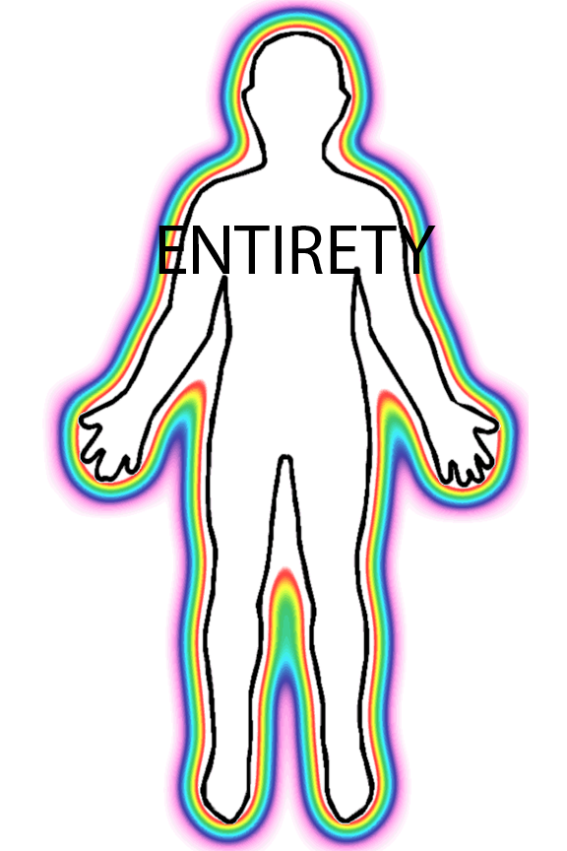
Ersdal devoted the next twenty-six years of his life studying anatomy and physiology. Ersdal was able to treat thousands of patients, which helped him in the development of over a hundred pathology charts. Through his research and further inspiration he discovered additional signals and treatments on the feet that had not been used with reflexology.
Ersdal was convinced by his research and inspiration that the body needed to be treated in its entirety. This assertion went against just treating the symptomatic areas that was the main focus of reflexology at that time. Ersdal named his technique Foot Zone Therapy. Ersdal opened the Center for Alternative Medicine in Kirstiansand, Norway. Because of his life’s work, Dr. Ersdal and his Foot Zone Therapy method became famous in Europe and throughout the world. Because of his many discoveries, reflexology charts have evolved to resemble more like Ersdal’s Foot Zone Therapy charts.

In 1989, Katri Nordblom, a former patient, student and instructor of Ersdal’s, invited Dr. Charles Ersdal to come to Montana and teach his first eleven students Foot Zone Therapy in the USA.

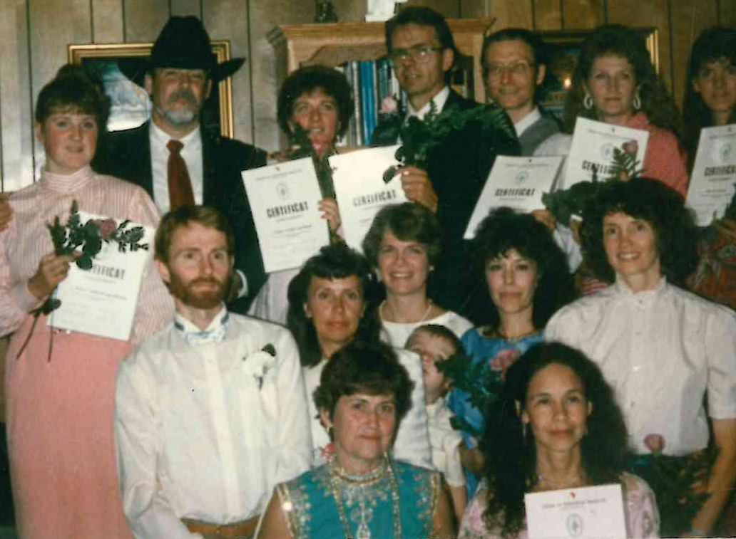

In 1991, Dr. Ersdal’s (in cowboy hat) with his first graduates of US students.

In the spring of 1992, the first Foot Zone Therapy class taught in Utah was in Amber Jensen’s home located in Sandy, UT. There were three other students in her class, Jeanne Harold, Libby Smith and Irene Weatherston. Together they were instructed and taught by Dr. Charles Ersdal himself, Katri Nordblom and Julie Holderegger. Amber passed her boards and received her Certificate Foot Zone Therapy in April 1994. She started teaching foot zone therapy in 1996.

In early 1995, Ersdal severed ties with Nordblom because a difference of opinion. Ersdal only granted another one of his foot zone instructors, Christine Horvath, the rights to use his charts and teaching curriculum to in the US. Horvath lives and continues to teach foot zoning in Wisconsin as of this publication (2018).

Dr. Charles Ersdal passed away on March 23, 1995. With his passing also went the knowledge of additional pathologies and techniques that he was working on but had not yet shared with his students of the US. Today, several individuals have continued his work, receiving additional inspiration and knowledge regarding the Foot Zone. They have opened up schools of their own because of their belief and passion to share with others this incredible modality in which it can help heal in a natural and noninvasive manner. Although, some techniques have varied, each has found great healing results with their clients.
MODERN FOOT ZONE GENEOLOGY

After Dr. Ersdal’s passing in 1996, Katri Nordblnom created her own foot zone curriculum and training program, American Nordblom Institute of FootZonalogy, located in Livingston, Montana. Nordblom was successful in recuiting a few of Dr. Ersdal’s students to come and teach for her. One of whom was Jeanne Harold. Harold proved to be a goldmine for Nordblom because of her close ties to her Northern Utah LDS community and was successful in attracting hundreds to Nordblom’s foot zone training program. Harold taught for 13 years before braking ties with Nordblom and go out on her own creating Zone Restoration.

Amber Jensen was approached by Nordblom and asked if she would also teach for the Nordblom Institute. Jensen declined. She could see that some key componants of what Ersdal taught were cut from Nordblom’s curriculum and her foot zone charts lacked the professional quality of Ersdal’s standards. Nordblom’s training program approached and taught foot zoning from a dietary approach. Even though diet is a very important part of one’s health this change of focus, taught in the name of foot zoning, proved to be the beginning of divergence of what the scope of foot zone practice was meant to be.

Brad and Sue Noal were former students of the Nordblom Institute. The Noal’s were never instructors for Nordblom, but had a strong desire to teach foot zoning and intitially teamed up with ?????????? (also a former student and instructor for Nordblom), using ?????’s curriculum and started We Do Feet Seminars. Soon after they started We Do Feet, the Noals severed ties with ??????

Stephanie Marcum was a former student and instructor for We Do Feet. When she moved to Hawaii in ????, she realized that the teaching curriculum and teaching styles of We Do Feet did not fit her student’s needs in Hawaii. She eventually broke from the Noal’s and created Foot Hold.

Kathy Duval was a former student and instructor for Nordblom. Kathy became disinlustioned with Nordblom’s curriculum and treatment of instructors. She broke ties with Nordblom and went on to create her own foot zone training program, Academy of Foot Zone Therapy.

Julie Cheney was a former student and instructor for Academy of Foot Zone Therapy. In ??? Cheney broke from Duval and teamed up with Kisi Watson and the two of them created ????????

Here are a list of several other foot zone training programs that somehow broke from the Nordblom leniage
Allison??????????????
Teresa Olsen????????? Broke off from Nordblom
Suzanne Pulsipher???????
????????Happy Feet broke off from We Do Feet
Claudia Goodman, student and instructor for Nordblom, broke from Nordblom and created ??????????

In 1996 Amber Jensen created her own foot zoning charts and curriculum, keeping true to the Ersdal teachings and standards. Because of the legal ramificaiton in the State of Utah at the time, Jensen did not “certify” her students as foot zone practitioners, but would teach her students the foot zone, giving them permission to only work on themselves and family. Jensen taught foot zoning to her students with this condition 1996-2014.

Since Ersdal’s death Amber Jensen has seen much of what Dr. Ersdal taught become lost, such as: landmarks, or orientation points on the foot, points of pressure, some foot zone signals, and pathologies.

MAKING FOOT ZONING LEGAL IN UTAH

Prior to April 1, 2014, it was considered illegal to foot zone in the State of Utah if a foot zone practitioner did not have a license to touch, such as: Nurse’s License, or Massage Therapy License. However, several training programs would teach their students that there was a loophole that could allow them to practice. The loop hole…offer a free foot zone with a paid energy healing session. One such training program that taught this was We Do Feet. Brad Noal claims to have talked to the Department of Occupational and Professional Licensing (DOPL) and received confirmation that offering a free foot zone with an energy session was legal. He claims to have a recording of such conversation. Susan Teide, owner of the Foot Zone Center, also talked with DOPL in length to get clarificaiton on this subject. She was informed that this so called loophole was false. It was illegal to offer a free foot zone with a paid energy healing session or anything else if one did not have a license to touch.

There was also other sentiment that the government had no right to govern foot zone therapy. Foot zoning was a wonderful healing modality that should be used and preformed without government interferance. This thinking was a common school of thought taught in the majority of foot zone training programs. To be quite honest, foot zoning was still fairly new and most practitioners felt that foot zoning fell through the cracks of the law and it was a gamble to practice.

Rachel ???? was a graduate of Academy of Foot Zone Therapy and practitcing foot zone practitioner in Kanab, Utah. In ???? she was issued a cease and desist letter from the Kanab City. Fining her $$$$$. Her instructor from Acamey of Foot zone Therapy was Julie Chenney. Chenney felt this was extremely harsh and sought out to rectify this situation. She sought out the help of Trudy Thurgood from St. George, who was also an instructor for Acemdemy of Foot Zone Therapy. From there Thurgood worked with Utah Representative Greene in writing a bill getting the law changed in the State of Utah in regardes to foot zoning.

In 2014, Amber Jensen and Sharla Pearce, with 30 years combined experience, co-founded Wellness Life Zone, Foot Zone Academy. Both Sharla and Amber believe and have said, “The innate blue print of the zone was placed in each of us by our creator. It was never invented, merely discovered. And as new students learn about and become proficient in this study, they too began to ask great questions and have had personal inspiration about the zone and discovered what to do for their clients. And many more practitioners will come along and continue to add to what has already been discovered. Each Foot Zone Practitioner brings his or her own gifts and talents to this technique, each having a unique energy that cannot be duplicated by another. And it is this energy that attracts those to them whom they are to help and teach.
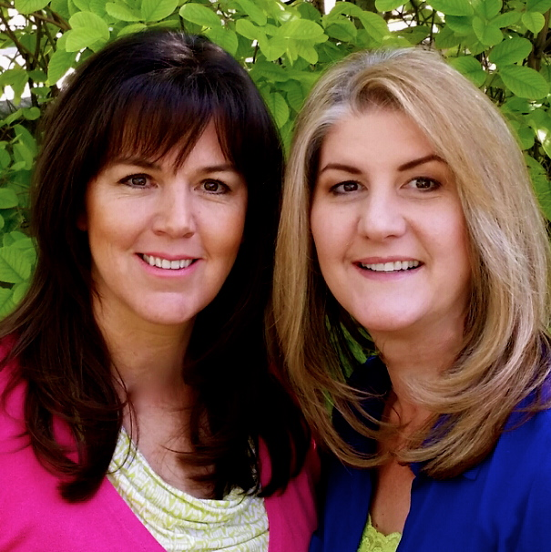

RESOUCES:

“Reflexology: Art, Science & History”, by Christine Issel

“ZONE THERAPY or Relieving Pain at Home”, by WM. H Fitzgerald M.D. and Edwin F. Bowers, M.D.

“Stories the Feet Can Tell Thru Reflexology”, by Eunice D. Ingham

